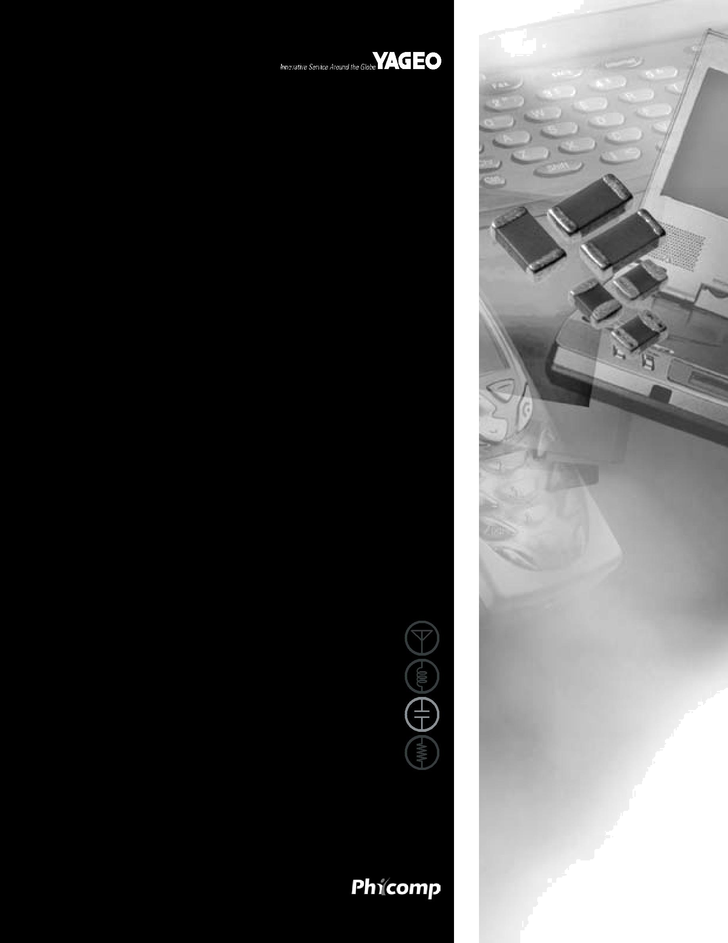

DATA SHEET

SURFACE-MOUNT CERAMIC MULTILAYER CAPACITORS
Class 2, Y5V

16/25/50 V

Preliminary specification – Dec 26, 2005 V.11

Phycomp | Product specification
Surface-mount ceramic | Class 2, Y5V
multilayer capacitors | 16/25/50 V

FEATURES

- Five standard sizes

- High capacitance per unit volume

- Supplied in tape on reel

- NiSn terminations.

APPLICATIONS

- Consumer electronics, for example:

− Tuners

− Television receivers − Video recorders

− All types of cameras − Mobile telephones.

DESCRIPTION

The capacitor consists of a rectangular block of ceramic dielectric in which a number of interleaved metal electrodes are contained. This structure gives rise to a high capacitance per unit volume.

The inner electrodes are connected to the two terminations and finally covered with a layer of plated tin (NiSn). A cross section of the structure is shown in Fig.1.

QUICK REFERENCE DATA

DESCRIPTION | VALUE
Rated voltage U_{R} (DC) | 16 V, 25 V, 50 V
Capacitance range (E6 series) | 10 nF to 10 µF; note 1
Tolerance on capacitance | ±20% (M); −20% to +80% (Z)
Test voltage (DC) for 1 minute: | 2.5 ⋅ U_{R}
Sectional specifications | IEC 60384-10, second edition 1989-04
Detailed specification | based on IEC 60384-10-1
End terminations | NiSn
Climatic category (IEC 60068) | 30/85/21

Note

1. Measured at 25 °C, 1 V and 1 kHz, using a four-gauge method.

terminations

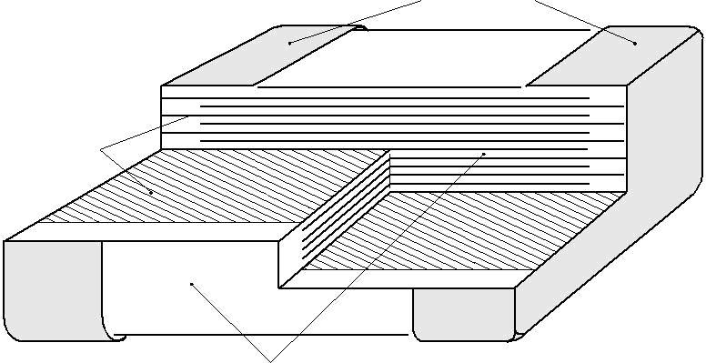

electrodes

MLB457

ceramic material

Fig.1 Construction of a ceramic multilayer capacitor.

2005 Dec 26 Rev.11 2 www.yageo.com

Phycomp Product specification

Surface-mount ceramic | Class 2, Y5V
multilayer capacitors | 16/25/50 V
MECHANICAL DATA
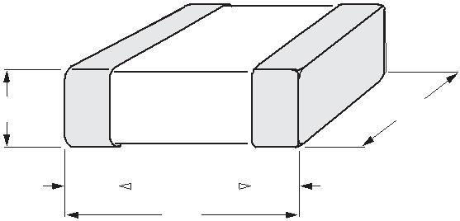

T W

^{L}2  ^{L}4 ^{L}3
_{L1} MBB211

For dimensions see Table 1.

 |  |  |  | Fig.2. |  | Component outline.
Physical dimensions
Table 1 Capacitor dimensions; see Fig.2
CASE SIZE | L₁ |  | W |  |  |  | T |  |  | L₂ and L₃ . |  | ^{L}4
CASE SIZE | L₁ |  |  |  |  | MIN. |  | MAX. | MIN. |  | MAX. | MIN.
Dimensions in millimetres
0402 | 1.0 ±0.05 | 0.5 ±0.05 |  |  |  | 0.45 |  | 0.55 | 0.15 |  | 0.30 | 0.40
0603 | 1.6 ±0.10 | 0.8 ±0.07 |  |  |  | 0.73 |  | 0.87 | 0.25 |  | 0.65 | 0.40
0805 | 2.0 ±0.10 | 1.25 |  | ±0.10 |  | 0.50 |  | 1.35 | 0.25 |  | 0.75 | 0.55
1206 | 3.2 ±0.15 | 1.6 ±0.15 |  |  |  | 0.50 |  | 1.75 | 0.25 |  | 0.75 | 1.40
1210 | 3.2 ±0.20 | 2.5 ±0.20 |  |  |  | 1.40 |  | 1.60 | 0.25 |  | 0.75 | 1.40
Dimensions in inches
0402 | 0.040 ±0.002 | 0.020 |  | ±0.002 |  | 0.018 |  | 0.022 | 0.008 |  | 0.012 | 0.016
0603 | 0.063 ±0.004 | 0.032 |  | ±0.003 |  | 0.029 |  | 0.035 | 0.010 |  | 0.026 | 0.016
0805 | 0.079 ±0.004 | 0.049 |  | ±0.004 |  | 0.020 |  | 0.053 | 0.010 |  | 0.030 | 0.022
1206 | 0.126 ±0.006 | 0.063 |  | ±0.006 |  | 0.020 |  | 0.069 | 0.010 |  | 0.030 | 0.056
1210 | 0.126 ±0.008 | 0.098 |  | ±0.008 |  | 0.047 |  | 0.069 | 0.010 |  | 0.030 | 0.056

2005 Dec 26 Rev.11 3 www.yageo.com
Phycomp Product specification

Surface-mount ceramic |  |  |  |  |  |  |  |  |  | Class 2, Y5V
multilayer capacitors |  |  |  |  |  |  |  |  |  | 16/25/50 V
SELECTION CHART FOR 16 V AND 25 V
 | LAST |  |  |  | 16 V |  |  |  | 25 V
C | TWO
C | DIGITS
(nF) | DIGITS | 0402 | 0603 |  | 0805 | 1206 | 1210 | 0603 | 0805 | 1206 | 1210
(nF) | OF | 0402 | 0603
 | 12NC
1 | 23
1.5 | 25
2.2 | 27
3.3 | 29
4.7 | 32
6.8 | 34
10 | 36 | 0.5 ±0.05 |  |  |  |  |  | 0.8 ±0.07
15 | 38
22 | 41
33 | 43
47 | 45
68 | 47
100 | 49 |  |  |  |  |  |  |  | 0.6 ±0.1 | 0.6 ±0.1
150 | 52 |  | 0.8 ±0.07 |  |  |  |  |  | 0.85 ±0.1
220 | 54
330 | 56
470 | 58 |  |  |  | 0.85 ±0.1 |  |  |  |  | 0.85 ±0.1
680 | 61
1,000 | 63 |  |  |  |  | 0.85 ±0.1 |  |  |  | 1.15 ±0.1
2,200 | 67 |  |  |  |  | 1.15 ±0.1 |  |  |  | 0.85 ±0.1
4,700 | 72 |  |  |  |  | 0.85 ±0.1 |  |  |  | 0.85 ±0.1
10,000 | 76 |  |  |  |  | 1.15 ±0.1 | 1.5 ±0.1 |  |  | 1.15 ±0.1 | 1.5 ±0.1

Note

1. Values in shaded cells indicate thickness class in mm.

2005 Dec 26 Rev.11 4 www.yageo.com
Phycomp Product specification

Surface-mount ceramic |  |  |  |  |  | Class 2, Y5V
multilayer capacitors |  |  |  |  |  | 16/25/50 V
SELECTION CHART FOR 50 V
 | LAST |  |  | 50 V
C | TWO
C | DIGITS
(nF) | DIGITS | 0603 |  | 0805 |  | 1206
(nF) | OF | 0603 |  | 0805 |  | 1206
 | 12NC
10 | 05 | 0.8 ±0.07 |  | 0.6 ±0.1
15 | 06
22 | 07
33 | 08
47 | 09
68 | 11
100 | 12 |  |  |  |  | 0.6 ±0.1
150 | 13 |  |  | 0.85 ±0.1
220 | 14
330 | 15
470 | 16 |  |  |  |  | 0.85 ±0.1
680 | 17
1 000 | 18 |  |  |  |  | 1.15 ±0.1

Note

1. Values in shaded cells indicate thickness class in mm.

Thickness classification and packing quantities

 | THICKNESS |  | 8 mm TAPE WIDTH QUANTITY PER REEL |  |  |  | QUANTITY PER BULK CASE
 | CLASSIFICATION |  | 180 mm; 7" |  | 330 mm; 13" |  | 0402 | 0603 | 0805
 | (mm) |  |  |  |  |  | 0402 | 0603 | 0805
 | (mm) |  | PAPER | BLISTER | PAPER | BLISTER | 0402 | 0603 | 0805
 | 0.5 ±0.05 |  | 10 000 | − | 50 000 | − | 50 000 | − | −
 | 0.6 ±0.10 |  | 4 000 | − | 20 000 | − | − | − | 10 000
 | 0.8 ±0.07 |  | 4 000 | − | 15 000 | − | − | 15 000 | −
 | 0.85 ±0.10 |  | 4 000 | − | 15 000 | − | − | 15 000 | 8 000
 | 1.15 ±0.10 |  | − | 3 000 | − | 10 000 | − | − | −
 | 1.25 ±0.10 |  | − | 3 000 | − | 1 000 | − | − | 5 000
 | 1.5 ±0.10 |  | − | 3 000 | − | − | − | − | −

2005 Dec 26 Rev.11 5 www.yageo.com
Phycomp | Product specification
Surface-mount ceramic | Class 2, Y5V
multilayer capacitors | 16/25/50 V

ORDERING INFORMATION

Components may be ordered by using either a Phycomp’s unique 12NC or simple 15-digit clear text code.

Ordering code 12NC (preferred)

handbook, full pagewidth

2 2 X X X X X X 9 X X X


Carrier type |  | Capacitance value⁽¹⁾
22 | blister
38 | paper
54 | bulk

Rated voltage - Termination |  |  | Tolerance
78 | 16 V; NiSn |  | 7 | ±20%
91 | 25 V; NiSn |  | 8 | −20/+80%
58 | 50 V; NiSn
Size
7 | 0402 |  | Packaging⁽²⁾
6 | 0603
0 | 0805 |  | 1 | reel: 180 mm; 7"
1 | 1206 |  | 5 | reel: 330 mm; 13"
2 | 1210 | CCA620_a | 4 | bulk case

- Refer to chapters “Selection chart for 16 V and 25 V” and “Selection chart for 50 V”.

- Quantity on reel depends on thickness classification, see section “Thickness classification and packing quantities”.

Phycomp Clear text code

EXAMPLE: 12062F105M8BB0D

Size | Temp. | Capacitance |  | Tol. | Vol. | Termination | Packing | Marking | Series
Code | Char.
0402 | 2F = Y5V | 105 = 1000000 |  | M = ±20% | 7 = 16 V | B = NiSn | 2 = 180 mm; 7" paper | 0 = no marking | D = BME
0603 |  | pF; the third digit |  | Z = −20% /+80% | 8 = 25 V |  | 3 = 330 mm; 13" paper
0805 |  | signifies the |  |  | 9 = 50 V |  | B = 180 mm; 7" blister
0805 |  | multiplying factor: |  |  |  |  | F = 330 mm; 13" blister
1206 |  |  |  |  |  |  | F = 330 mm; 13" blister
1206 |  | 2 | = × 100 |  |  |  | P = bulk case
1210 |  | 2 | = × 100
1210 |  | 3 | = × 1000
 |  | 4 | = × 10 000
 |  | 5 | = × 100 000
 |  | 6 | = × 1 000 000

2005 Dec 26 Rev.11 6 www.yageo.com

Phycomp | Product specification
Surface-mount ceramic | Class 2, Y5V
multilayer capacitors | 16/25/50 V

ELECTRICAL CHARACTERISTICS

Class 2 capacitors; Y5V dielectric; NiSn terminations

Unless otherwise stated all electrical values apply at an ambient temperature of 25 ±1 °C, an atmospheric pressure of 86 to 105 kPa, and a relative humidity of 63 to 67%.

DESCRIPTION | VALUE
Capacitance range (E6 series); note 1 | 10 nF to 10 µF
Tolerance on capacitance after 1000 hours | ±20% (M); −20% to +80% (Z)
Tan δ; note 1:
all 25 V and 50 V
except 0805 ≥ 330 nF; 0603 /100 nF; 1206 /1 µF; 1210 /10 µF | ≤5%
sizes 0805 / 330 nF; 0603 / 100 nF; 1206 /1 F | ≤7%
25 V
0805 ≥ 470 nF | ≤9%
1210 /10 µF | ≤12.5%
all 16 V
except 0402; 0603 ≥ 330 nF; 0805 ≥ 1.5 ∝F; 1206 ≥ 3.3 ∝F; 1210 /10 ∝F | ≤9%
sizes 0402; 0603 ≥ 330 nF; 0805 ≥ 1.5 ∝F; 1206 ≥ 3.3 ∝F; 1210 /10 ∝F | ≤12.5%
Insulation resistance after 1 minute at U_{R} (DC): | R_{ins} >10 GΩ or R_{ins} ⋅ C ≥500 seconds
Insulation resistance after 1 minute at U_{R} (DC): | whichever is less
Maximum capacitance change with respect to capacitance at 25 °C | +22% to −82%
(for typical values see Fig.5) | +22% to −82%
Ageing | typical 7% per time decade
Resistance to soldering heat | 260 °C; 10 seconds

Note

- Measured at 25 °C, 1 V, 1 kHz, using a four-gauge method.

2005 Dec 26 Rev.11 7 www.yageo.com

Phycomp | Product specification
Surface-mount ceramic | Class 2, Y5V
multilayer capacitors | 16/25/50 V

MBD076
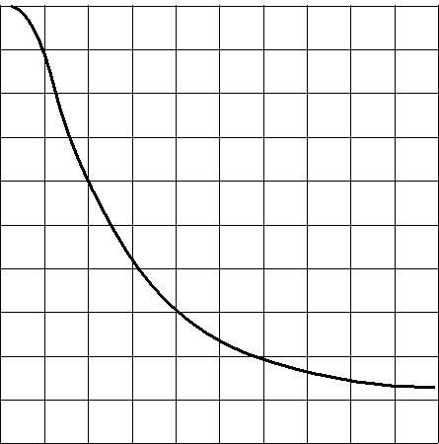
∆ C ⁰

C
(%)

20

40

60

80

100

0 | 10 | 20 | 30 | 40 | 50
 |  |  |  | V_{DC} (V)

Fig.3 Typical capacitance change with respect to the capacitance at 1 V as a function of DC voltage at 25 °C.

MBD077
25
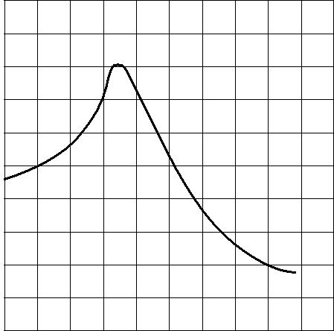
∆ C C
(%)
0

25

50

75

100

25 0 25 50 75 100 T (ºC)

MBD078
2000
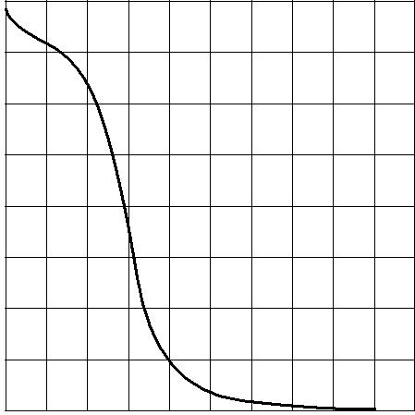

tan δ

(x 10 ⁴ )

1500

1000

500

0
25 0 25 50 75 100 T (ºC)

Fig.4 Typical tan δ as a function of temperature.

Fig.5 Typical capacitance change
as a function of temperature.

2005 Dec 26 Rev.11 8 www.yageo.com

Phycomp Product specification

Surface-mount ceramic |  |  |  | Class 2, Y5V
multilayer capacitors |  |  |  | 16/25/50 V
TESTS AND REQUIREMENTS
Table 2 Test procedures and requirements
IEC | IEC
60384-10/ | 60068-2 | TEST | PROCEDURE | REQUIREMENTS
CECC 32 100 | TEST | TEST | PROCEDURE | REQUIREMENTS
CLAUSE | METHOD
4.4 |  | mounting | the capacitors may be mounted | no visible damage
 |  |  | on printed-circuit boards or
 |  |  | ceramic substrates by applying
 |  |  | wave soldering, reflow soldering
 |  |  | (including vapour phase
 |  |  | soldering) or conductive
 |  |  | adhesive
4.5 |  | visual inspection and | any applicable method using ⋅10 | in accordance with
 |  | dimension check | magnification | specification
4.6.1 |  | capacitance | f = 1 kHz; Y5V measuring | within specified tolerance
 |  |  | voltage 1 V_{rms} at 25 °C
4.6.2 |  | tan δ | f = 1 kHz; Y5V measuring | in accordance with
 |  |  | voltage 1 V_{rms} at 25 °C | specification
4.6.3 |  | insulation resistance | at U_{R} (DC) for 1 minute | R_{i}C_{R} ≥500 s
4.6.4 |  | voltage proof | 2.5 ⋅ U_{R} for 1 minute | no breakdown or flashover
4.7.1 |  | temperature | between minimum and maximum | in accordance with
 |  | coefficient | temperature | specification
4.8 |  | adhesion | a force of 5 N applied for 10 s to | no visible damage
 |  |  | the line joining the terminations
 |  |  | and in a plane parallel to the
 |  |  | substrate
4.9 |  | bond strength of | mounted in accordance with IEC | no visible damage
 |  | plating on end face | 60384-1, paragraph 4.35
 |  |  | conditions: | ∆C/C: ≤30%
 |  |  | bending 1 mm at a rate of 1
 |  |  | mm/s, radius jig 340 mm
4.10 | Tb | resistance to | preconditioning: | the terminations shall be
 |  | soldering heat | 120 to 150 °C during 1 minute; | well tinned
 |  |  | 120 to 150 °C during 1 minute; | after recovery ∆C/C: ±20%
 |  |  | 260 ±5 °C for 10 ±0.5 s in a | after recovery ∆C/C: ±20%
 |  |  | static solder bath | tan δ: original specification
 |  |  |  | R_{ins}: original specification
 |  | resistance to | 260 ±5 °C for 30 ±1 s | using visual enlargement
 |  | leaching | in a static solder bath | of ⋅10, dissolution of the
 |  |  |  | terminations shall not
 |  |  |  | exceed 10%

2005 Dec 26 Rev.11 9 www.yageo.com
Phycomp Product specification

Surface-mount ceramic |  |  |  | Class 2, Y5V
multilayer capacitors |  |  |  | 16/25/50 V
IEC | IEC
60384-10/ | 60068-2 | TEST | PROCEDURE | REQUIREMENTS
CECC 32 100 | TEST | TEST | PROCEDURE | REQUIREMENTS
CLAUSE | METHOD
4.11 | Ta | solderability | zero hour test, and test after | the terminations shall be
 |  |  | storage (20 to 24 months) in | well tinned
 |  |  | original packing in normal
 |  |  | atmosphere;
 |  |  | unmounted chips completely
 |  |  | immersed for 2 ±0.5 s in a
 |  |  | solder bath at 235 ±5 °C
4.12 | Na | rapid change of | preconditioning: | no visible damage
 |  | temperature | between minimum and | after 48 hours recovery:
 |  |  | maximum temperature, 5 cycles | °C/C: ≤ ±20%
4.14 | Ca | damp heat, | initialization: | no visible damage
 |  | steady state | 48 ±4 hours after U_{R} at 40 °C | after 48 hours recovery:
 |  |  | for 1 hour (for initial value | °C/C: +30%/−40%
 |  |  | measurement); | tan δ: ≤15%
 |  |  | 500 ±12 hours at 40 °C; | R_{ins}: 500 MΩ or R_{i}C_{R} ≥ 100 s,
 |  |  | 90 to 95% RH; U_{R} applied | whichever is less
 |  | damp heat; | initialization: | preconditioning:
 |  | with U_{R} load | 48 hours after U_{R} at 40 °C; | U_{R} at 40 °C for 1 hour, after
 |  |  | for 1 hour (for initial value | 48 hours recovery:
 |  |  | measurement); | 48 hours recovery:
 |  |  | measurement); | °C/C: +30%/−40%
 |  |  | 500 ±12 hours at 40 °C; | °C/C: +30%/−40%
 |  |  | 500 ±12 hours at 40 °C; | tan δ: ≤15%
 |  |  | 90 to 95% RH; U_{R} applied | tan δ: ≤15%
 |  |  | 90 to 95% RH; U_{R} applied | R_{ins}: 500 MΩ or R_{i}C_{R} ≥ 25 s,
 |  |  |  | whichever is less
4.15 |  | endurance | initialization: | after 48 hours recovery:
 |  |  | 2 ⋅ U_{R} at 85 °C for 1 hour, | °C/C: +30%/−40%
 |  |  | (initial value measurement after | tan δ: ≤15%
 |  |  | 48 ±4 hours) ; | R_{ins}: 1000 MΩ or R_{i}C_{R} ≥ 50 s,
 |  |  | 2 ⋅ U_{R} at 85 °C for 1000 hours | whichever is less
 |  |  | recovery 48 ±4 hours at room
 |  |  | temperature

2005 Dec 26 Rev.11 10 www.yageo.com
Phycomp Product specification

Surface-mount ceramic |  |  | Class 2, Y5V
multilayer capacitors |  |  | 16/25/50 V
REVISION HISTORY
Revision | Date | Change | Description
 |  | Notification
Rev.11 | Dec 26, 2005 |  | Revised thickness of Y5V 0805 25/50 V 0.33 µF
Rev 10 | Sep 21, 2005 | − | Y5V 0805 16 V thickness revised and range extended from 2.2
 |  |  | µF to 4.7 µF
Rev.9 | June 24, 2005 | − | - Revised thickness of:
 |  |  | Y5V 1206 16 V from 4.7 µF to10 µF
 |  |  | Y5V1206 25 V from 2.2 µF to 10 µF
Rev.8 | Jan 13, 2005 | − | - Revised thickness of Y5V 0805 16 V 1 µF and Y5V 0805 25 V 470
 |  |  | nF to 1 µF
Rev.7 | Jul 08, 2003 | − | - Updated company logo

2005 Dec 26 Rev.11 11 www.yageo.com

