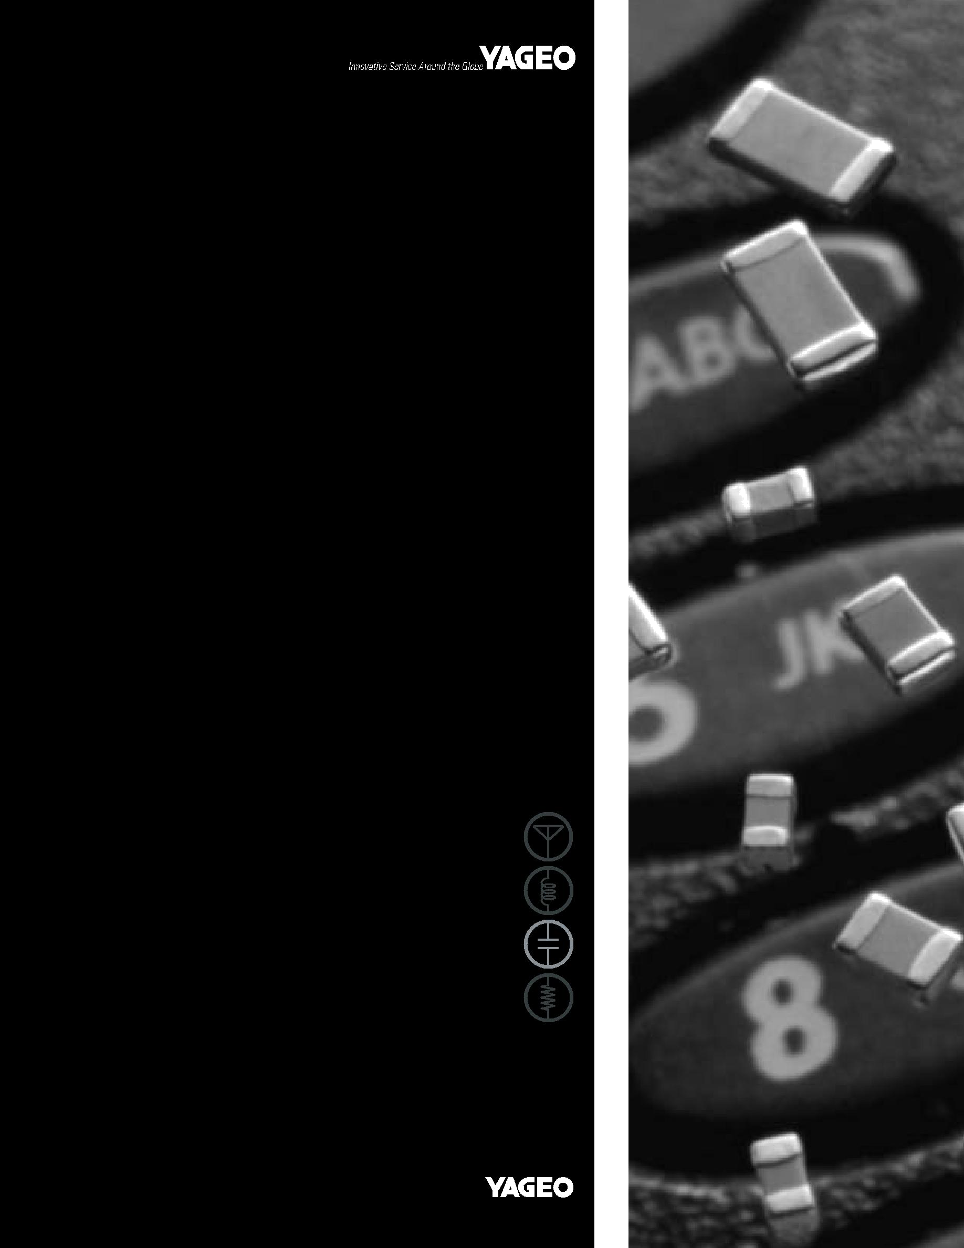

DATA SHEET

MULTILAYER CERAMIC CAPACITORS

CC Series

X7R

16 V TO 100 V

Product specification – Aug 17, 2005 V.9 Supersedes Date of Jan 21, 2005

 |  |  |  |  |  | 2
 | Surface Mount Multilayer Ceramic Capacitors | CC | SERIES | X7R, 16 V to 100 V | 10


SCOPE

This specification describes Yageo CC X7R series chip capacitors.

ORDERING INFORMATION

Part number is identified by the series, size, tolerance, packing style, temperature coefficient, rated voltage and capacitance value.

CC ⋅ ⋅ ⋅ ⋅ ⋅ ⋅ X7R ⋅ BB ⋅ ⋅ ⋅

(1) (2) (3) (4) (5)

(1) SIZE – INCH BASED (METRIC)

0402 (1005)

0603 (1608)

0805 (2012)

1206 (3216)

1210 (3225)

1812 (4532)

(2) TOLERANCE

J = ±5%

K = ±10%

(3) PACKING STYLE

R = 7” paper tape

K = 7” blister tape

P = 13” paper tape

F = 13” blister tape

C = Bulk case

(4) RATED VOLTAGE

7 = 16 V

8 = 25 V

9 = 50 V

0 = 100 V

(5) CAPACITANCE VALUE:

First two for significant figures and 3rd for number of zero

Letter “R” for decimal point

CONSTRUCTION

 | terminations
 | electrodes
Fig. 1 Surface mounted multilayer | MLB457
ceramic capacitor construction | ceramic material
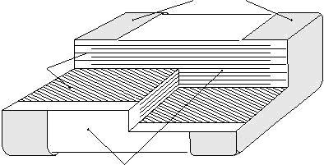


DIMENSION

For dimension see Table 1
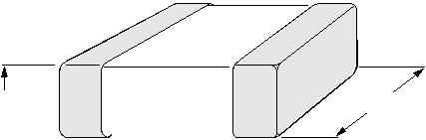

T W

Fig. 2
Fig. 2 | Surface mounted multilayer ceramic |  |  |  |  |  |  |  | L ₂ |  |  | L ₄ |  |  |  | L ₃ |  |  | MBB211
 | capacitor dimension |  |  |  |  |  |  |  |  |  |  |  |  |  |  |  |  |  | MBB211
 |  |  |  |  |  |  |  |  |  |  |  | L ₁
Table 1
TYPE |  | CC0402 | CC0603 | CC0805 |  |  |  |  |  | CC1206 |  |  |  | CC1210 |  |  |  |  |  | CC1812
L1 (mm) |  | 1. 0±0.05 | 1.6±0.10 | 2.0±0.10 |  |  |  |  |  | 3.2±0.15 |  |  |  | 3.2±0.20 |  |  |  |  |  | 4.5±0.20
W (mm) |  | 0.5±0.05 | 0.8±0.07 | 1.25±0.10 |  |  |  |  |  | 1.6±0.15 |  |  |  | 2.5±0.20 |  |  |  |  |  | 3.2±0.20
T (mm) | min. | 0.45 | 0.73 | 0.50 |  |  |  |  |  | 0.50 |  |  |  | 0.50 |  |  |  |  |  | 0.50
T (mm) | max. | 0.55 | 0.87 | 1.35 |  |  |  |  |  | 1.35 |  |  |  | 1.80 |  |  |  |  |  | 1.80
 | min. | 0.15 | 0.20 | 0.25 |  |  |  |  |  | 0.25 |  |  |  | 0.25 |  |  |  |  |  | 0.25
L2/L3 (mm) _{max.} |  | 0.30 | 0.60 | 0.75 |  |  |  |  |  | 0.75 |  |  |  | 0.75 |  |  |  |  |  | 0.75
L4 (mm) | min. | 0.40 | 0.40 | 0.55 |  |  |  |  |  | 1.40 |  |  |  | 1.40 |  |  |  |  |  | 2.20

www.yageo.com Aug 17, 2005 V.9


 |  |  |  |  |  | 3
 | Surface Mount Multilayer Ceramic Capacitors | CC | SERIES | X7R, 16 V to 100 V | 10

CAPACITANCE RANGE & THICKNESS FOR 16V & 25V

Table 2
CAPACITANCE |  | 16 V |  |  |  | 25 V
(nF) |  | 0402 | 0603 | 0805 | 1206 | 0402 | 0603 | 0805 | 1206 | 1210
3.3 |  |  |  |  |  | 0.5 ±0.05
3.9
4.7
5.6
6.8 |  | 0.5 ±0.05
8.2
10 |  |  |  |  |  |  | 0.8 ±0.07 | 0.6 ±0.1
12
15
18
22
27
33 |  |  | 0.8 ±0.07
39
47 |  |  |  | 0.6 ±0.1 |  |  |  | 0.85 ±0.1
56
68
82 |  |  |  | 0.85 ±0.1
100 |  |  |  |  |  |  |  |  | 0.85 ±0.1
120
150
180
220 |  |  |  |  | 0.85 ±0.1 |  |  |  |  | 0.85 ±0.1
270 |  |  |  |  |  |  |  |  | 1.15 ±0.1
330 |  |  |  | 1.25 ±0.1
390 |  |  |  |  | 1.15 ±0.1
470


560


680



820



1,000

www.yageo.com Aug 17, 2005 V.9

 |  |  |  |  |  | 4
 | Surface Mount Multilayer Ceramic Capacitors | CC | SERIES | X7R, 16 V to 100 V | 10

CAPACITANCE RANGE & THICKNESS FOR 50V & 100V

Table 3
CAPACITANCE |  | 50 V |  |  |  |  |  | 100 V
(nF) |  | 0402 | 0603 | 0805 | 1206 | 1210 | 1812 | 0805 | 1206 | 1210 | 1812
0.10 |  | 0.5 ±0.05 | 0.8 ±0.07
0.12
0.15
0.18
0.22 |  |  |  | 0.6 ±0.1 | 0.85 ±0.1 |  |  | 0.6 ±0.1 | 0.85 ±0.1
0.27
0.33
0.39
0.47
0.56
0.68
0.82
1.0
1.2
1.5
1.8
2.2
2.7
3.3
3.9
4.7
5.6
6.8
8.2
10 |  |  |  |  |  | 0.85 ±0.1
12 |  |  |  |  |  |  |  | 0.85 ±0.1
15
18
22
27 |  |  |  | 0.85 ±0.1
33
39
47 |  |  |  |  |  |  |  |  |  | 0.85 ±0.1

www.yageo.com Aug 17, 2005 V.9

 |  |  |  |  |  | 5
 | Surface Mount Multilayer Ceramic Capacitors | CC | SERIES | X7R, 16 V to 100 V | 10

CAPACITANCE RANGE & THICKNESS FOR 50V & 100V (CONTINUED)

Table 4
CAPACITANCE | 50 V |  |  |  |  |  | 100 V
(nF) | 0402 | 0603 | 0805 | 1206 | 1210 | 1812 | 0805 | 1206 | 1210 | 1812
56 |  |  | 0.85 ±0.1 | 0.85 ±0.1 | 0.85 ±0.1 |  |  | 1.15 ±0.1 | 0.85 ±0.1
68
82
100 |  | 0.8 ±0.07 |  |  |  | 1.15 ±0.1 |  |  |  | 1.15 ±0.1
120 |  |  |  |  | 1.15 ±0.1 |  |  |  | 1.15 ±0.1
150 |  |  |  | 1.15 ±0.1
180
220
270
330
390 |  |  |  |  |  |  |  |  |  | 1.6 ±0.2
470
560 |  |  |  |  |  | 1.6 ±0.2
680
820
1,000

www.yageo.com Aug 17, 2005 V.9

 |  |  |  |  |  | 6
 | Surface Mount Multilayer Ceramic Capacitors | CC | SERIES | X7R, 16 V to 100 V | 10

THICKNESS CLASSES AND PACKING QUANTITY

Table 5
THICKNESS | 8mm TAPE WIDTH / AMOUNT PER REEL |  |  |  |  | 12mm TAPE WIDTH /
CLASSIFICATION |  |  |  |  |  | AMOUNT PER REEL | AMOUNT PER BULK CASE
(mm) | Ø180mm, 7” |  | Ø330mm, 13” |  |  | Ø180mm, 7” Blister
 | Paper | Blister | Paper | Blister |  | 1812 | 0402 |  | 0603 | 0805
0.5 ±0.05 | 10,000 | --- | 50,000 | --- | --- |  | 50,000 | --- |  | ---
0.6 ±0.10 | 4,000 | --- | 20,000 | --- | --- |  | --- | --- |  | 10,000
0.8 ±0.07 | 4,000 | --- | 15,000 | --- | --- |  | --- | 15,000 |  | ---
0.85 ±0.10 | 4,000 | --- | 15,000 | --- | --- |  | --- | --- |  | 8,000
1.15 ±0.10 | --- | 3,000 | --- | 10,000 | --- |  | --- | --- |  | ---
1.25 ±0.10 | --- | 3,000 | --- | 10,000 | --- |  | --- | --- |  | 5,000
1.6 ±0.20 | --- | --- | --- | --- | 1,000 |  | --- | --- |  | ---

ELECTRICAL CHARACTERISTICS

Table 5
CHARACTERISTICS | TEST CONDITIONS | REQUIREMENT
Operation temperature range | --- | –55 °C to +125 °C
Temperature characteristic/coefficient (TC) | With respect to 20 °C within operation | ±15%
Temperature characteristic/coefficient (TC) | temperature range | ±15%
Capacitance tolerance | 1 Vrms/1 KHz at 20 °C | ±5%, ±10%
Dissipation factor (Tan d) | 1 Vrms/1 KHz at 20 °C | 25 V, 50 V & 100 V; ≤2.5%
Dissipation factor (Tan d) | 1 Vrms/1 KHz at 20 °C | 16 V; ≤3.5%
Insulation resistance (IR) | At Ur (rated voltage) for 1 minute | C ≤ 10 nF; Rins | ≥ 10 GΩ
Insulation resistance (IR) | At Ur (rated voltage) for 1 minute | C > 10 nF; Rins | x C ≥ 500 s
Dielectric withstanding Voltage | At 2.5 × Ur (for Ur ≤ 100V) | No breakdown
Dielectric withstanding Voltage | 1.5 × Ur + 100 V for 5 sec | No breakdown

www.yageo.com Aug 17, 2005 V.9

 |  |  |  |  |  | 7
 | Surface Mount Multilayer Ceramic Capacitors | CC | SERIES | X7R, 16 V to 100 V | 10

TAPING REEL

Table 6
TAPE WIDE | 8mm | 8mm | 12mm |  | T
ØA (mm) | 180 | 330 | 180
ØB (mm) | 62±1.5 | 62±1.5 | 62±1.5
ØD (mm) | 20.5 | 20.5 | 20.5 | D | CBA
ØC (mm) | 12.75±0.15/–0 | 12.75±0.15/–0 | 12.75±0.15/–0
W (mm) | 8.4+1.5/–0 | 8.4+1.5/–0 | 12.4+2/–0
Tmax (mm) | 14.4 | 14.4 | 18.4 |  | MSA284_b
 |  |  |  |  | W
 |  |  |  | Fig. 3 Reel dimension | For dimension see Table 6
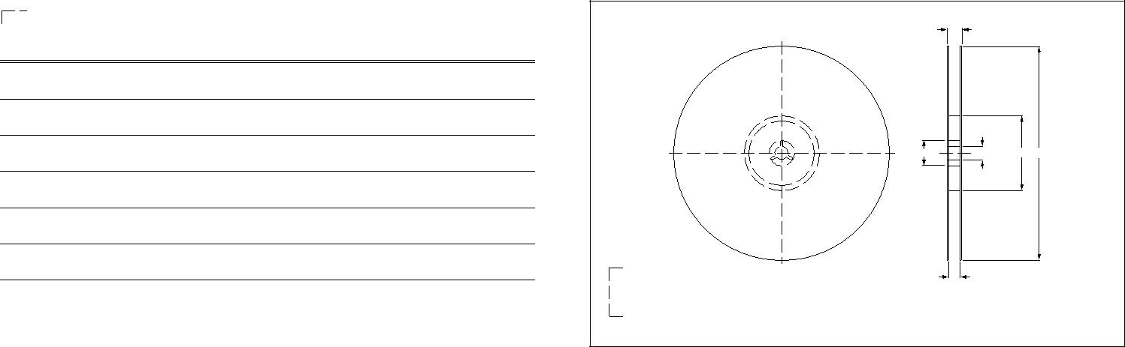

PAPER TAPE SPECIFICATION

Table 7 |  |  |  |  |  | For dimension see Table 7
DIMENSION | 0402 | 0603 | 0805 | 1206 |  |  |  |  |  |  |  |  |  |  |  |  |  |  |  |  |  |  |  |  |  |  |  |  |  |  |  |  |  |  |  |  |  | P₀
A (mm) | 0.62±0.05 | 1.10±0.05 | 1.65±0.05 | 2.0±0.1 |  |  | T |  |  |  |  |  |  |  |  |  | D ₀ |  |  |  |  |  |  |  |  |  |  |  |  |  |  |  |  |  | P₂
B (mm) | 1.12±0.05 | 1.90±0.05 | 2.4±0.05 | 3.5±0.1 |  |  |  |  |  |  |  |  |  |  |  |  |  |  |  |  |  |  |  |  |  |  |  |  |  |  |  |  |  |  |  |  |  |  |  | E
W (mm) | 8.0±0.2 | 8.0±0.2 | 8.0±0.2 | 8.0±0.2
 |  |  |  |  | cover tape |  |  |  |  |  |  |  |  |  |  |  |  |  |  |  |  |  |  |  |  |  |  |  |  |  |  |  |  |  |  |  |  |  |  |  |  |  |  |  |  |  |  |  |  |  | F
E (mm) | 1.75±0.1 | 1.75±0.1 | 1.75±0.1 | 1.75±0.1 |  |  |  |  |  |  |  |  |  |  |  |  |  |  |  |  |  |  |  |  |  |  |  |  |  |  |  |  |  |  |  |  |  |  |  |  |  |  |  |  |  |  |  |  |  |  |  |  |  |  |  |  |  | W
F (mm) | 3.5±0.05 | 3.5±0.05 | 3.5±0.05 | 3.5±0.05 |  |  |  |  |  |  |  |  |  |  |  |  |  |  |  |  |  |  |  |  |  |  |  |  |  |  |  |  |  |  |  |  |  |  |  |  |  |  |  |  |  |  |  |  |  |  |  |  |  | B
 |  |  |  |  |  |  |  |  |  |  |  |  |  |  |  |  |  |  |  |  |  |  |  |  |  |  |  |  |  |  |  |  | A |  |  |  |  |  |  |  |  | ^{P}1 |  |  |  |  |  |  |  |  |  |  |  |  |  | MBG251_a
P0 (mm) | 4±0.05 | 4±0.05 | 4±0.05 | 4±0.05
P1 (mm) | 2±0.05 | 4±0.1 | 4±0.1 | 4±0.1 |  | Fig. 4 |  |  |  |  |  | Paper tape dimension
P2 (mm) | 2±0.05 | 2±0.05 | 2±0.05 | 2±0.05
ØD0 (mm) | 1.5+0.1 | 1.5+0.1 | 1.5+0.1/–0 | 1.5+0.1/–0
T (mm) | 0.6±0.05 | 0.95±0.05 | 0.95±0.05 | 0.95±0.05
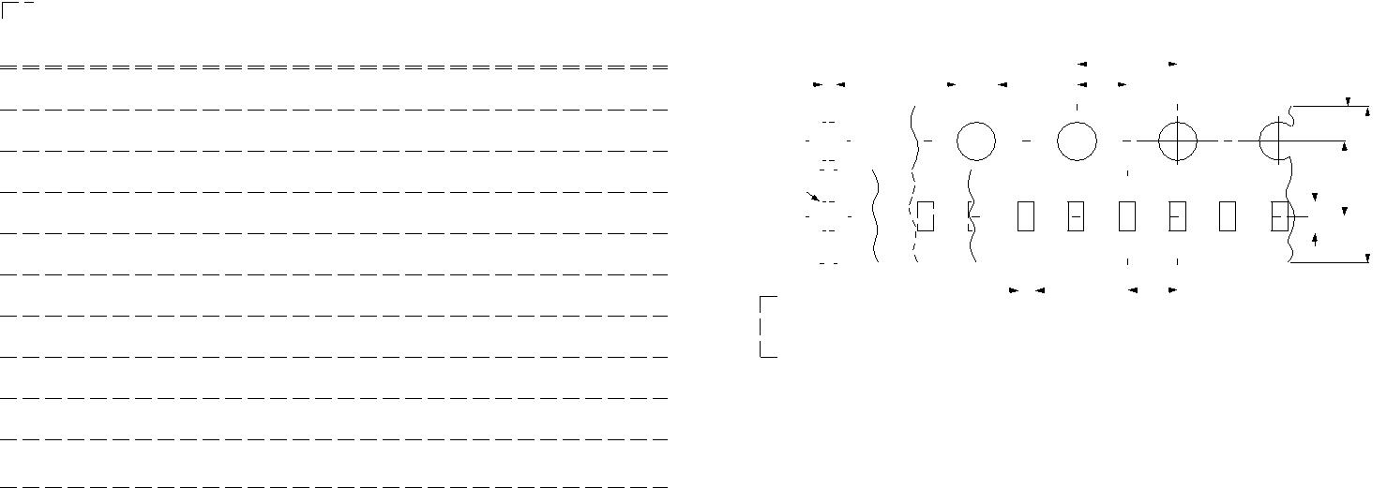

BLISTER TAPE SPECIFICATION

Table 8 |  |  |  |  | For dimension see Table 8
DIMENSION | 0805 | 1206 | 1210 | 1812 | For dimension see Table 8
A (mm) | 0.20 | 0.30 | 0.30 | 0.40 |  | P₀
 |  |  |  |  | D ₀ | P₂
B (mm) | 0.20 | 0.30 | 0.30 | 0.40 |  | E
W (mm) | 8.1±0.2 | 8.1±0.2 | 8.1±0.2 | 12.0±0.2 | pe | F
 |  |  |  |  | pe | W
E (mm) | 1.75±0.1 | 1.75±0.1 | 1.75±0.1 | 1.75±0.1 |  | W
 |  |  |  |  |  | B
F (mm) | 3.5±0.05 | 3.5±0.05 | 3.5±0.05 | 5.5±0.05
P0 (mm) | 4±0.1 | 4±0.1 | 4±0.1 | 4±0.1 |  | MBG516_a
 |  |  |  |  | A | D ₁
P1 (mm) | 4±0.1 | 4±0.1 | 4±0.1 | 8±0.1 | T | P₁
P2 (mm) | 2±0.05 | 2±0.05 | 2±0.05 | 2±0.05 | direction of unreeling
ØD0 (mm) | 1.5+0.1/–0 | 1.5+0.1/–0 | 1.5+0.1/–0 | 1.5+0.1/–0 | Fig. 5 Leader/trailer tape dimension
Tmax (mm) | 3.5 | 3.5 | 3.5 | 3.5
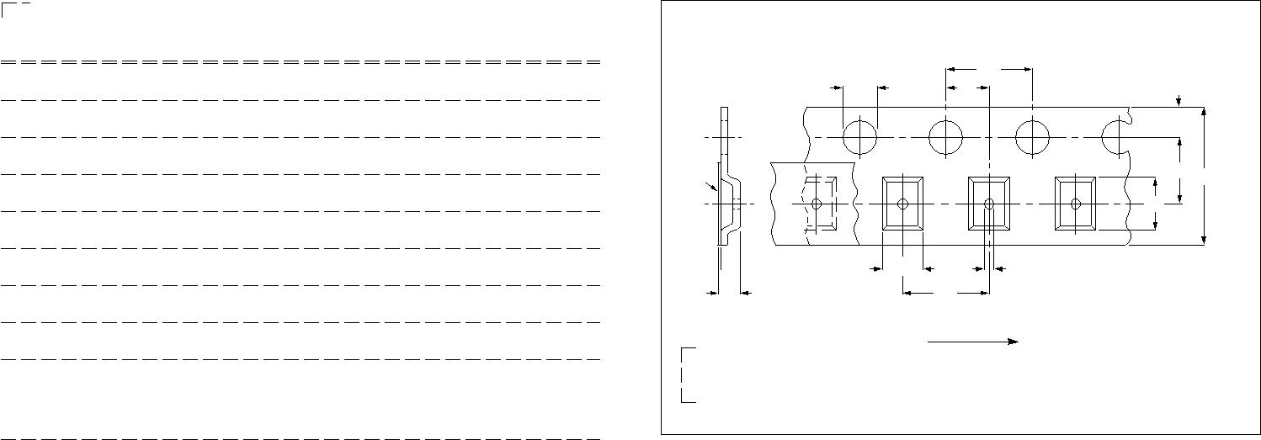

www.yageo.com Aug 17, 2005 V.9

 |  |  |  |  |  | 8
 | Surface Mount Multilayer Ceramic Capacitors | CC | SERIES | X7R, 16 V to 100 V | 10

PACKING METHOD

LEADER/TRAILER TAPE SPECIFICATION

 |  |  |  |  |  |  |  |  |  |  |  |  |  |  |  |  |  | leader end
 |  |  |  |  |  |  |  |  |  |  |  |  |  |  |  |  |  |  |  |  | cover tape only
trailer end |  |  |  |  |  |  |  |  |  |  |  |  |  |  |  | empty compartments |  |  |  |  |  | 120 40 mm
 |  |  |  |  |  |  |  |  |  |  |  |  |  |  |  | with cover tape
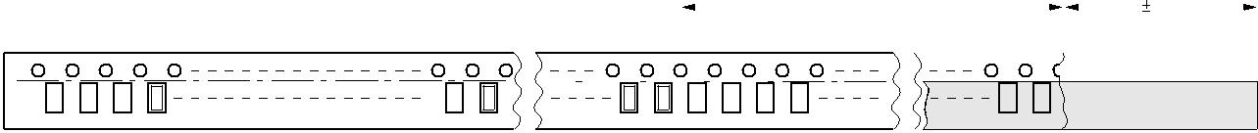

 |  | trailer (max. 260 mm) |  |  |  | leader 400 mm
 |  | trailer (max. 260 mm) |  |  |  | leader 400 mm | MEA529 - 2
Fig. 6 Leader and trailer tape dimension

METHOD OF MOUNTING

For normal use the capacitors may be mounted on printed-circuit boards or ceramic substrates by applying wave soldering, reflow soldering (including vapor phase soldering) or conductive adhesive in accordance with CECC 00802 classification A.

Typical values (sold line)

Process limits (dotted lines)

300 |  | 10 s | MLA859
T |  | 10 s | MLA859
(¡C) | 260 ¡C
250 | 245 ¡C
 | 215 ¡C | 10 s
200 |  | 40 s
 | 180 ¡C | 40 s
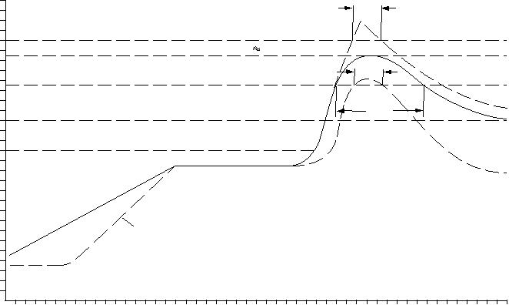

150
130 ¡C

100

2 K/s

50

0

0 50 100 150 200 250 t (s)

Fig. 7 Recommended reflow soldering profile

Typical values (sold line)
Process limits (dotted lines)
The capacitors may be soldered twice in accordance with this method if desired

300
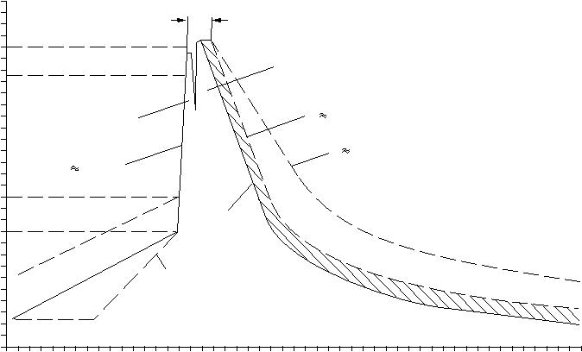
10 s
T |  |  |  |  | MLA861
(¡C) |  |  |  |  | MLA861
250 | 235 ¡C to 260 ¡C |  | second wave
200 | first wave |  | 5 K/s
 |  |  | 2 K/s
150 | 200 K/s
 | 100 ¡C to 130 ¡C | forced
100 |  | forced
100 |  | cooling
50 |  | 2 K/s
0
0 | 50 | 100 | 150 | 200 | t (s) | 250

Fig. 8 Recommended wave soldering profile

www.yageo.com Aug 17, 2005 V.9

 |  |  |  |  |  | 9
 | Surface Mount Multilayer Ceramic Capacitors | CC | SERIES | X7R, 16 V to 100 V | 10

TEST AND REQUIREMENT

Table 9
IEC384-10 | TEST ITEMS | CONDITIONS | REQUIREMENTS
4.9 | Bending | Bending rate 1mm/s, jig. radius 340mm | ∆C/C≤10%
4.10 | Resistance to soldering heat | 260±5°C for 10±0.5s in static solder | –5%≤∆C/C≤10%
4.10 | Resistance to soldering heat | bath | –5%≤∆C/C≤10%
4.11 | Solderability | 235±5°C for 2±0.5s in a static solder | 75% minimum coverage of metallic area
4.11 | Solderability | bath | 75% minimum coverage of metallic area
4.12 | Rapid change of temperature | Preconditioning | ∆C/C within 15%
4.12 | Rapid change of temperature | –55°C to +125°C, 5cycles | ∆C/C within 15%
 |  | Preconditioning | ∆C/C within 15%
4.14 | Damp heat | At 40°C, 90 to 95% RH and Ur applied | Tan δ≤7%
 |  | (max. 500V) for 500 hours | IR≥500MΩ or RxC≥25s whichever is less

 |  | Preconditioning
4.15 | Endurance | 2xUr applied for 1,000 hours, at upper
 |  | category temperature

∆C/C within 20%

Tan δ≤7%

IR≥1,000MΩ or RxC≥50s whichever is less

www.yageo.com Aug 17, 2005 V.9

 |  |  |  |  | 10
 | Surface Mount Multilayer Ceramic Capacitors | CC | SERIES | X7R, 16 V to 100 V |  | 10

REVISION HISTORY

REVISION | DATE | CHANGE NOTIFICATION | DESCRIPTION
Version 9 | Aug 17, 2005 | - | - 0603 50V capacitance range extended to 100 nF
Version 8 | Jan 21, 2005 | - | - Capacitance range extended
Version 7 | Feb. 24, 2004 | - | - upgrade the thickness on page 3-4
Version 6 | Aug. 13, 2003 | - | - Taping drawing amended
Version 5 | Jun. 19, 2003 | - | - Thickness of 1206/470 nF revised into “1.15±0.1”
 |  |  | - CTC code size 1812 revised
Version 4 | Jan. 27, 2003 | - | - Edit “SCOPE”
Version 3 | Dec. 18, 2002 | - | - New Yageo edition
Version 2 | Jul. 04, 2002 | - | -

www.yageo.com Aug 17, 2005 V.9

